Improving the capacity of international cooperation and economic cooperation of WB HEIs – INTECO

Project number: 101177758 — INTECO — ERASMUS-EDU-2024-CBHE

EVENT NAME

Organizer

Location/Address

dd/mm/yyyy

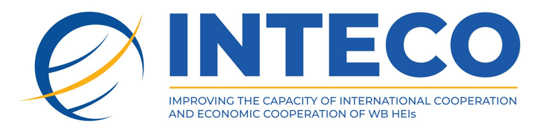

**www.inteco.eubd.edu.ba**

|  |  |  |
| --- | --- | --- |
| Day, dd/mm/yy | | |
| duration | description | place |
| 09:30–10:00 | Gathering and registration of participants | Room name |
| 10:00–10:30 | Welcome speeches Name Surname, Institution | Room name |
| 10:30–11:30 | Topic Name Surname, Institution | Room name |
| 11:30–12:00 | Topic Name Surname, Institution | Room name |
| 12:00–12:30 | Coffee break | Room name |
| 12:30–13:30 | Topic Name Surname, Institution | Room name |
| 13:30–14:30 | Topic Name Surname, Institution | Room name |
| 14:30–15:30 | Lunch Break | Restaurant name |
| 15:30–16:30 | Topic Name Surname, Institution | Room name |
| 16:30–17:30 | Topic Name Surname, Institution | Room name |
| 15:30–17:30 | Topic Name Surname, Institution | Room name |
| 17:30–18:00 | Discussion and conclusion of the first day | Room name |
| **20:00–22:00** | Other activity | Location name |