Improving the capacity of international cooperation and economic cooperation of WB HEIs – INTECO
Project number: 101177758 — INTECO — ERASMUS-EDU-2024-CBHE

EVENT NAME
Organizer
Location/Address
dd/mm/yyyy

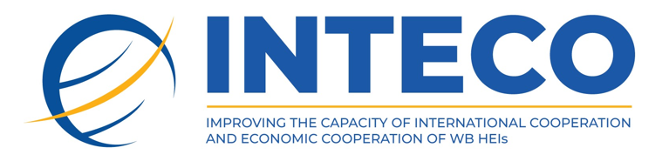

www.inteco.eubd.edu.ba

Funded by the European Union. Views and opinions expressed are however those of the author(s) only and do not necessarily reflect those of the European Union or the European Education and Culture Executive Agency (EACEA). Neither the European Union nor EACEA can be held responsible for them.

Day, dd/mm/yy
duration | description | place
09:30–10:00 | Gathering and registration of participants | Room name
10:00–10:30 | Welcome speeches  Name Surname, Institution | Room name
10:30–11:30 | Topic  Name Surname, Institution | Room name
11:30–12:00 | Topic  Name Surname, Institution | Room name
12:00–12:30 | Coffee break | Room name
12:30–13:30 | Topic  Name Surname, Institution | Room name
13:30–14:30 | Topic  Name Surname, Institution | Room name
14:30–15:30 | Lunch Break | Restaurant name
15:30–16:30 | Topic  Name Surname, Institution | Room name
16:30–17:30 | Topic  Name Surname, Institution | Room name
15:30–17:30 | Topic  Name Surname, Institution | Room name
17:30–18:00 | Discussion and conclusion of the first day | Room name
20:00–22:00 | Other activity | Location name

